Flex Service :
Infos sur Flex Web Service Version 3 (interactivebrokers.com)
Token activé le 20.12.2022 jusqu’au 20.11.2023
Flex Query ID=717782 (TradeLive Flex Query report)
Flex Query Id=741768 TradeSummary Flex Query report
TOken ID= 673431700918021006861356
To test :
- Launch Query with tokenID + queryID and get associated Reference Code
https://gdcdyn.interactivebrokers.com/Universal/servlet/FlexStatementService.SendRequest?t=673431700918021006861356&q=741768&v=3
OK le 20.12.2022 :
<FlexStatementResponse timestamp="19 December, 2022 11:58 PM EST">
<Status>Success</Status>
<ReferenceCode>9256836187</ReferenceCode>
<Url>https://gdcdyn.interactivebrokers.com/Universal/servlet/FlexStatementService.GetStatement</Url>
</FlexStatementResponse>
- Get result in XML format
https://ndcdyn.interactivebrokers.com/AccountManagement/FlexWebService/GetStatement?t=673431700918021006861356&q=1598259242&v=3

If not ready :
<FlexStatementResponse timestamp="20 December, 2022 12:04 AM EST">
<Status>Warn</Status>
<ErrorCode>1019</ErrorCode>
<ErrorMessage>Statement generation in progress. Please try again shortly.</ErrorMessage>
</FlexStatementResponse>
TradeLive
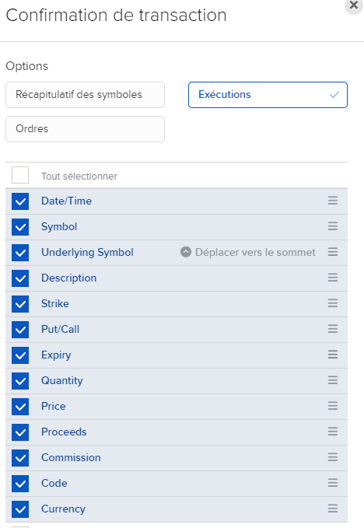
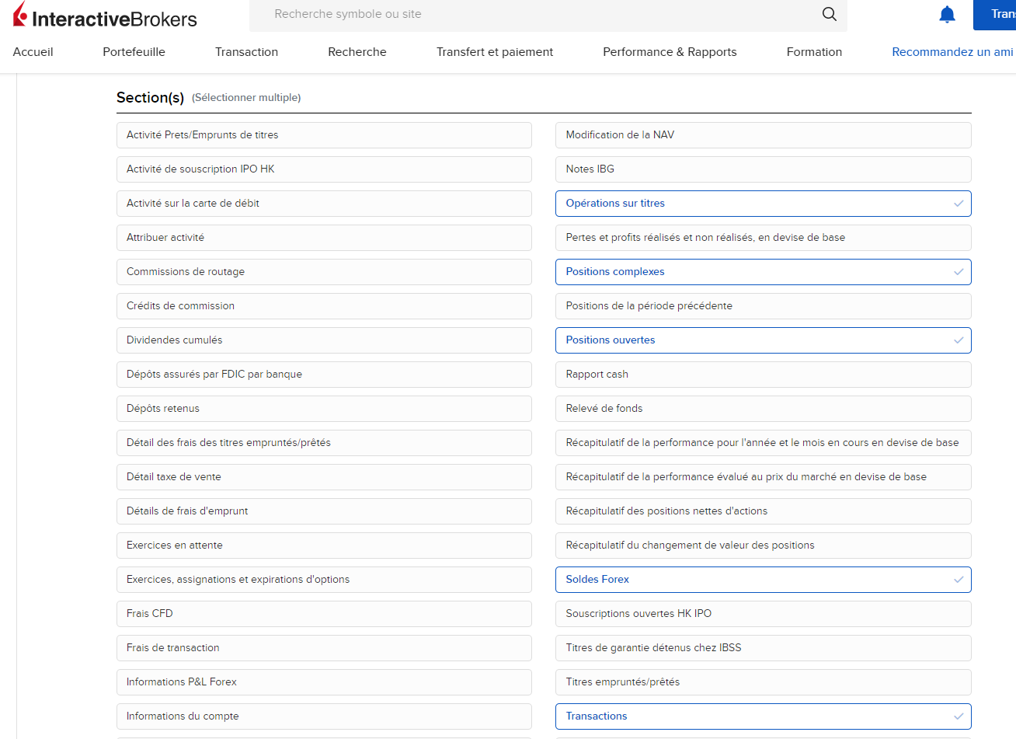

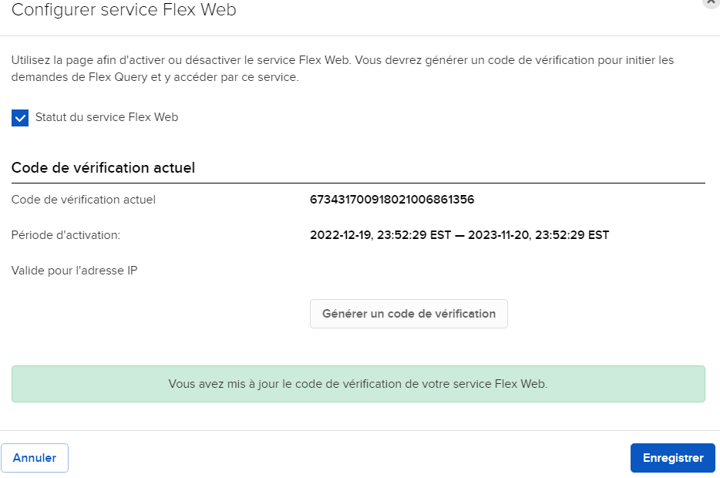
TWS PnL
Please note that both Realized and Unrealized P&L on Trader Workstation are for informational purposes only. They neither add, nor subtract, anything from your account. The actual P&L credited to or debited from the account is computed from the opening trade price to the closing trade price. This information can always be found in the daily activity statement for the account. The P&L values displayed use the market price value when computing the value that is being displayed. The system gives less weight to pre and post market transactions due to the lack of liquidity and the width of the spreads. As a result of this, the previous close is used until the NYSE market opens at 09:30 EST.
Background:
The Account Window utilizes the following formulas to calculate P&L: Unrealized P&L is the difference between the current market value of your open positions and the average cost, or Value – Average Cost; Realized P&L shows your profit on closed positions, which is the difference between your entry execution cost and exit execution cost, or (execution price + commissions to open the position) – (execution price + commissions to close the position).

The Order Management page on TWS utilizes two different P&L calculation methods. It is for the account holder to decide which calculation method they wish to have displayed: Daily P&L is calculated for all positions you currently hold using the new position calculation and the formula (current price) – (prior day’s closing price) x (total number of outstanding shares); while New Position P&L is calculated for transactions executed today using the formula (current price) – (purchase price) x (number of outstanding shares purchased today).
!! Daily PnL is reset at 0 :00 Eastern Time – 6 :00am CET now
